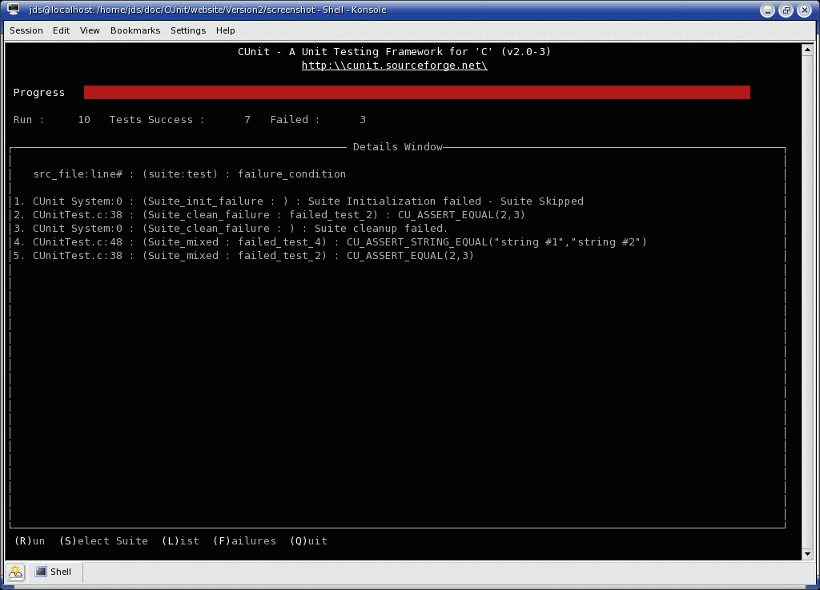**Release : Screen directory**

The picture is a thing called Curses. It was (or is) a sort of terminal driver / text ui library that allowed the use of completely different terminals with the same code, it worked with termcap or terminfo to provide device independence.

I used to work at a place that used it ; it was a really cheap place to work. Not only did we use a version of curses we typed in ourselves from a book – wrongly, which we didn’t know until I tried to do a vertical menu with it and it crashed all the time. When allocating memory for the window we’d used w * w rather than h * w, which worked fine provided w was greater than h, which it isn’t in some drop down menus.

The hardware we developed on was on loan from someone or other – a huge 386 box about the size of a fridge. We kept having to concoct reasons why we were still ”testing” this gear …… this company was a subset of a big commercial organisation too. If the owners had wanted it back we would have been stuffed….. we were running Xenix/386 on it and we wouldn’t have had a machine to develop on.

I also worked at a place where I was given an original IBM PC to work on, the 4.77Mhz one, with a specialised BASIC interpreter. I got an upgrade when I pointed out the machine could not keep up with my typing – type LIST and it took about 5 seconds to appear. Not awfully good for productivity (this same place I was ridiculed for suggesting DBASE III type screen painters …. this was in the late 1980s ….)

Anyway, the point of this is I have released, hopefully, a new screen driver for the HLL – this one does proper scrolling unlike the rolling of the monitor, which means it needs 128 bytes of RAM all to itself – because the design does not allow you to read video ram, you have to keep a shadow copy of everything. It’s about 400 bytes and provides string and character input and output. There’s a program testing it that just inputs a line and echos it again.